

Centre Name: ACE-HCMC-2-FPT (VN.033)

Address: 590 Cách Mạng Tháng 8 Street, District 3, Ho Chi Minh City, Viet Nam



WEB PHOTO

SHARE

User Guide

|  |  |  |  |
| --- | --- | --- | --- |
| **Faculty:** | | **Mr. Nguyen Ngo Phuoc** |  |
| **Batch No:** | | **F2-10-1203-T0** |  |
| **Group No:** | | **01** |  |
| **Student** |  | **Full Name** | **Roll No.** |
|  | 1. | NGUYEN VU HUNG | STUDENT636555 |
|  | 2. | TRAN VAN HAI | STUDENT630717 |
|  | 3. | LE NGOC NHUT | STUDENT636217 |
|  | 4. | NGUYEN ANH TUAN | STUDENT576665 |

September 2013

# Table of Contents

Table of Contents 2

I. Setup Database 3

1. Requirement 3

2. Create database 3

II. Deploy project into GlashFish Server 6

1. Requirement 6

2. Start GlashFish server 6

3. Deploy database resource 6

4. Deploy Application 8

# Front-Page

## Index page

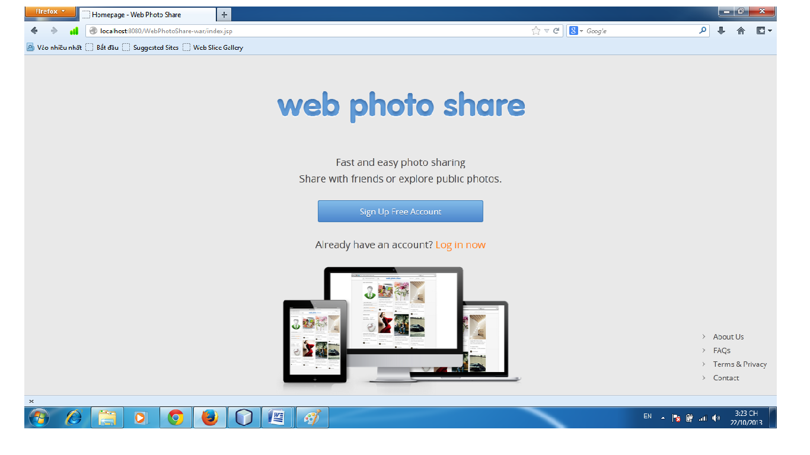

Click link login click on the link to the login page

if not yet registered, click on the link Sign Up Free Account

## Login page

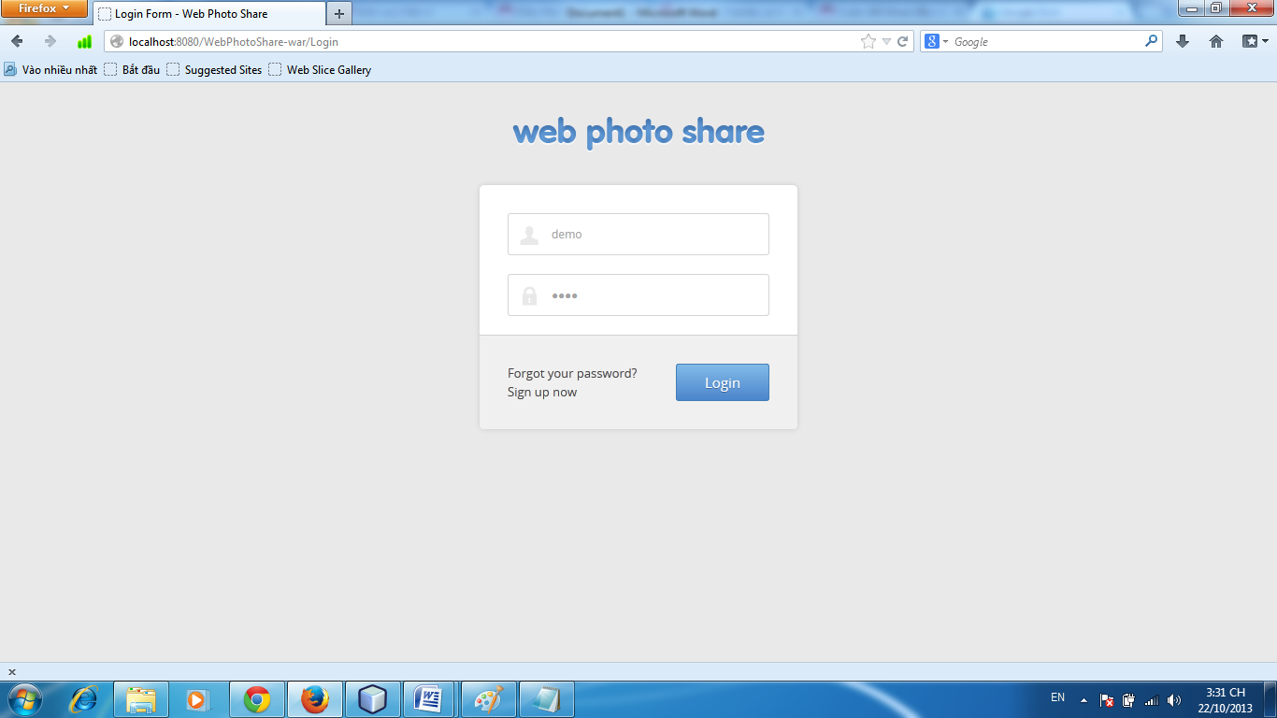

Enter your UserName and Enter your Password.

Click button Login.

## Home Page

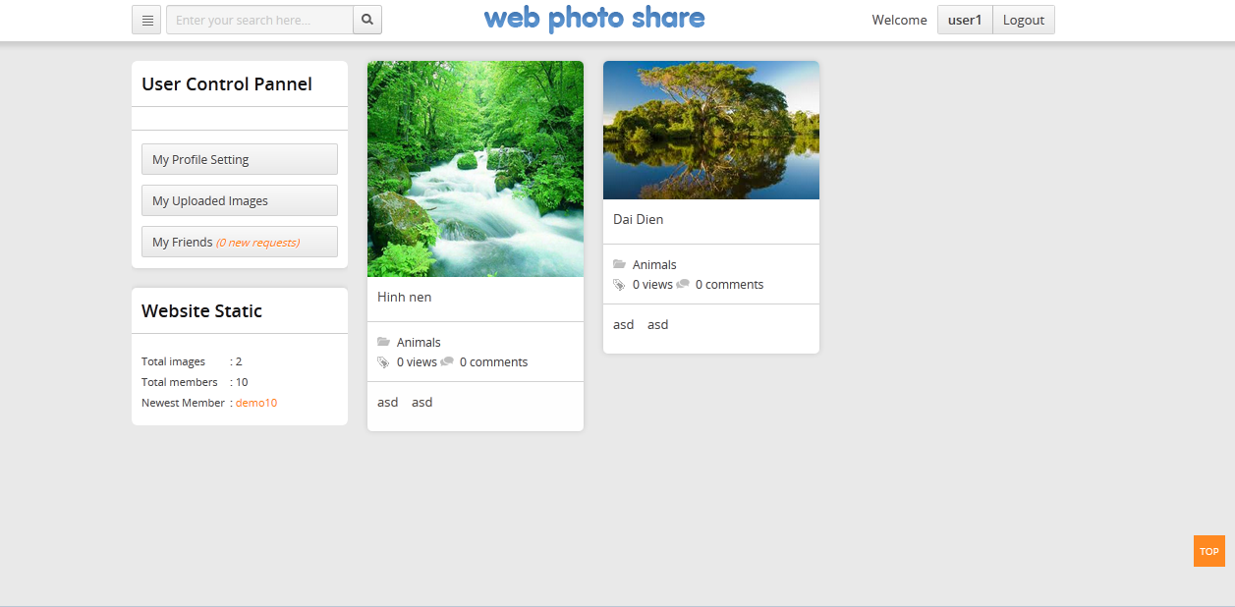

## My Upload Image

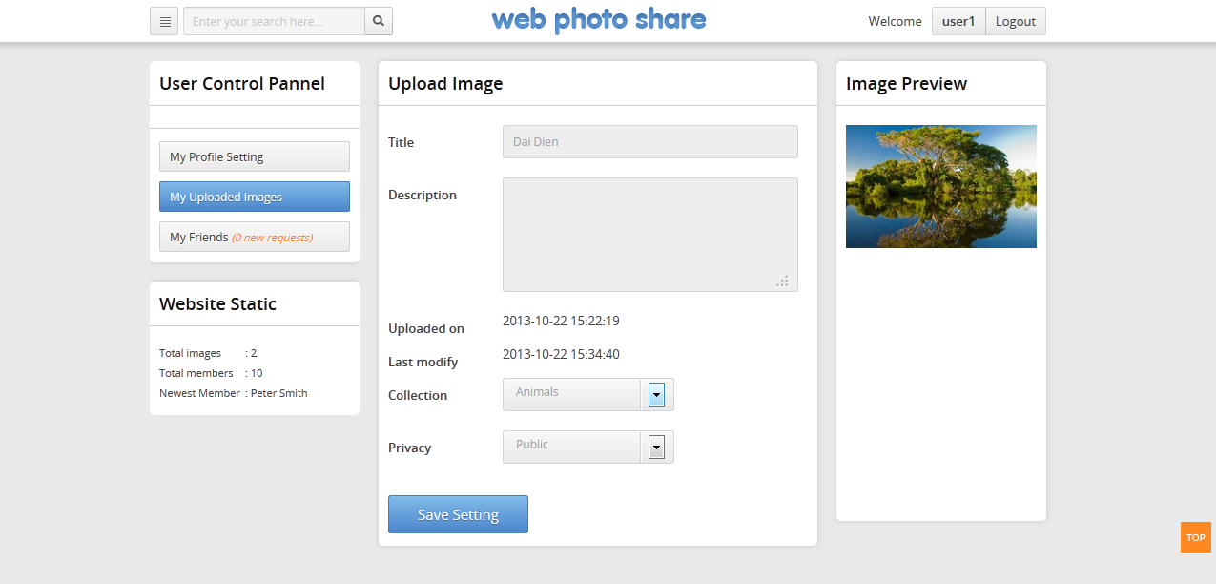

Enter title name Image

Enter Description of Image (can be null )

Select Collection of Image

Select Privacy of Image

Click button Save Setting to save the image

## My Profile Setting

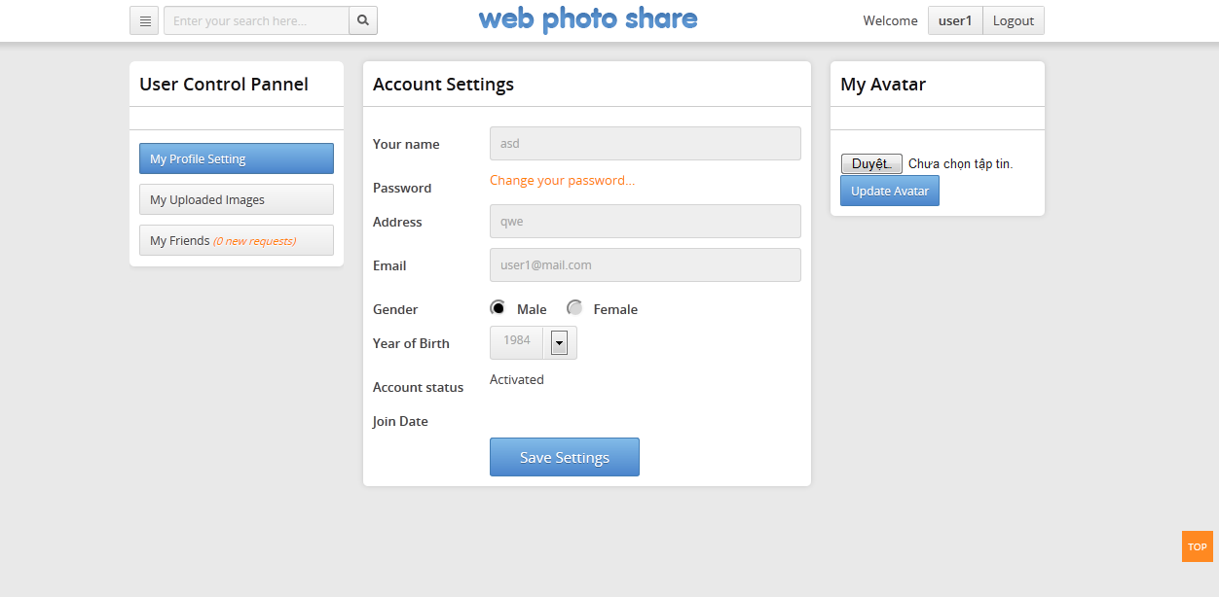

Enter Your name

Enter your address and Email.

Select gender and Year of brith

Click Save Settings to change info

Click browse choose avatar

Click Update Avatar change avatar

## My Friends

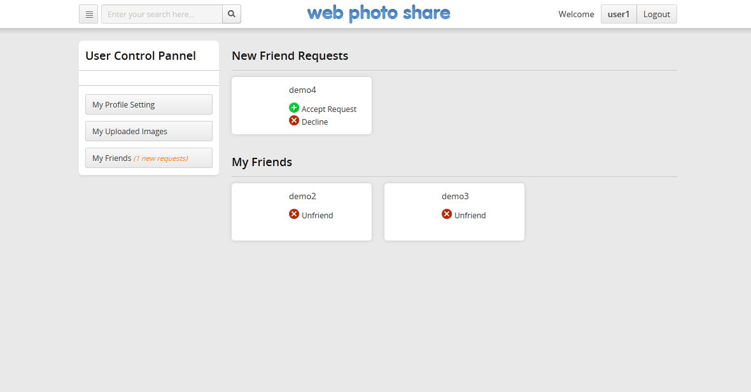

select Accept Request to add Friend

select Decline to denied

## Menu

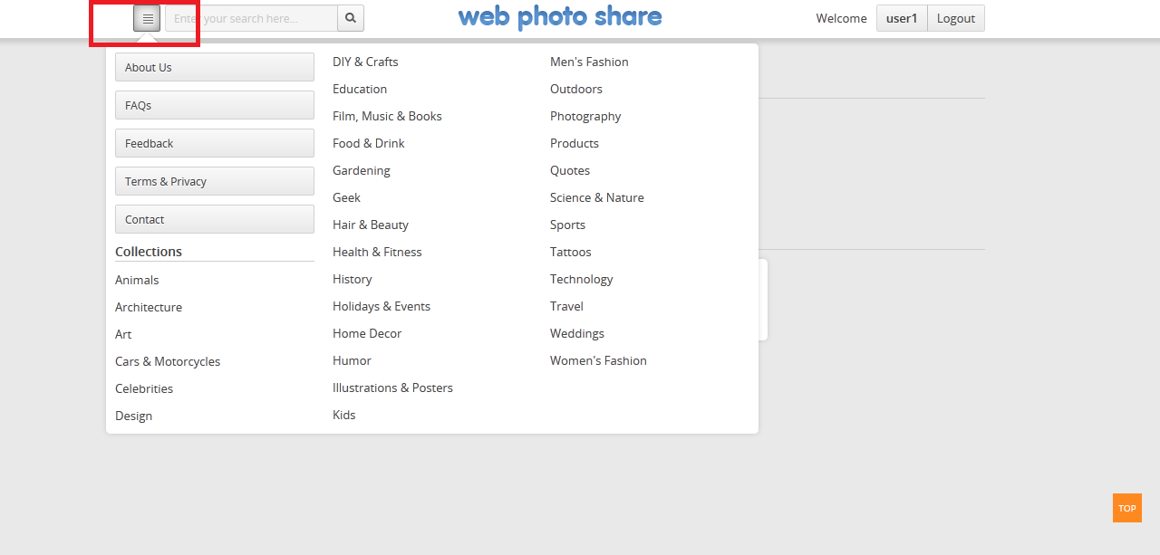

Click to display the menu bar

## About US

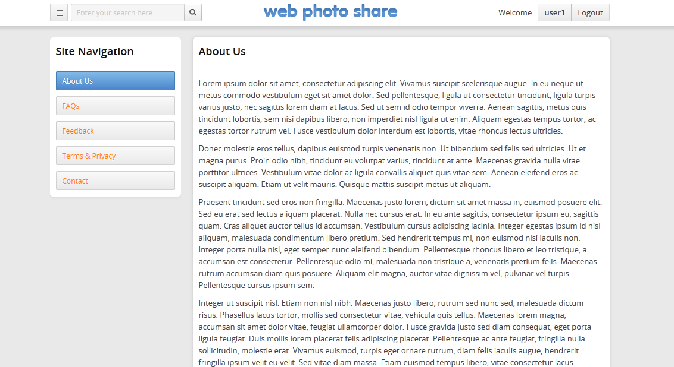

## FAQs

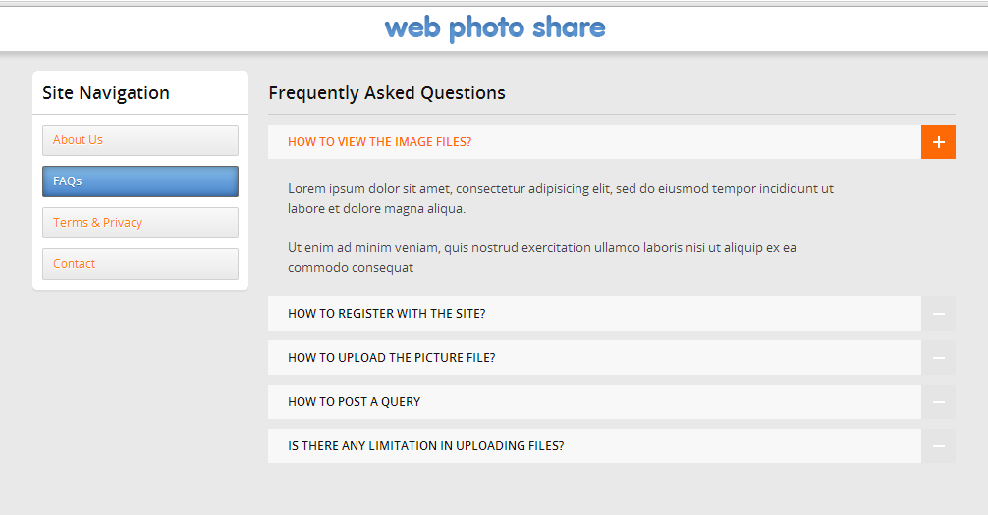

## Feedback

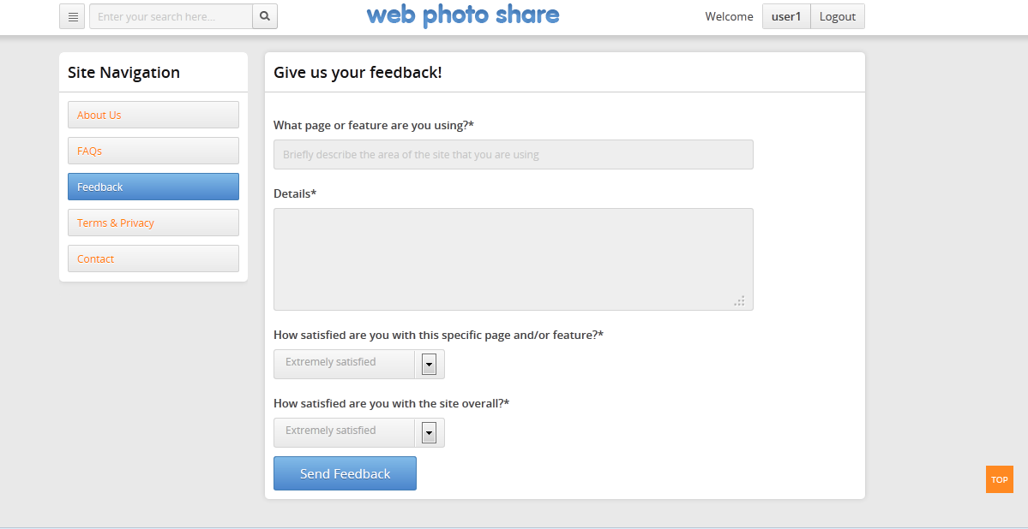

Enter the response

Enter your comments about the web

Select review

Click button Send Feedback to sned evaluation

## Terms & Privacy

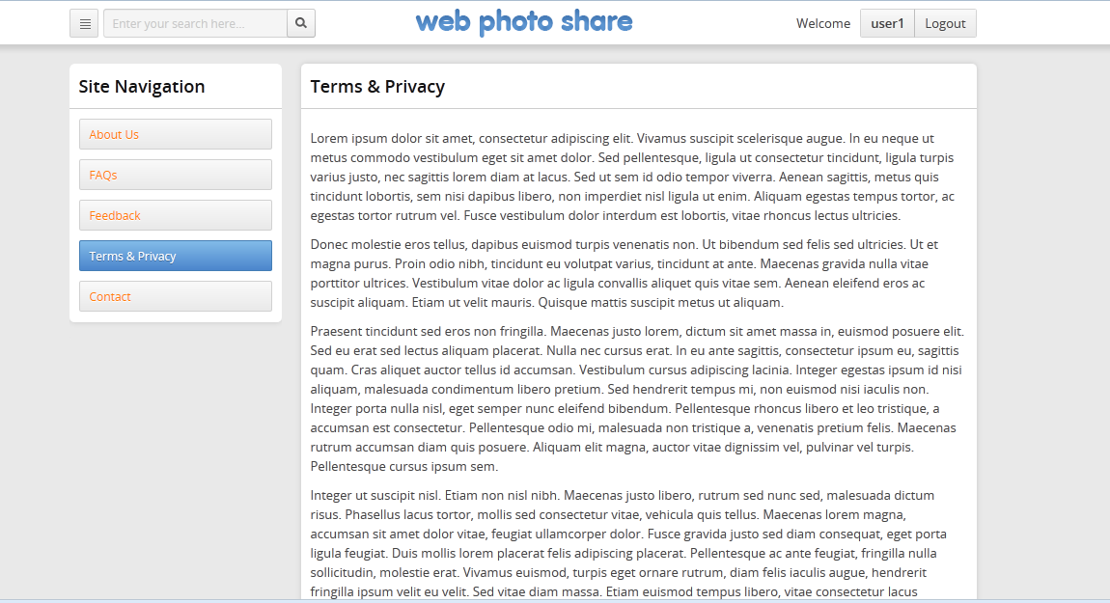

## Contact

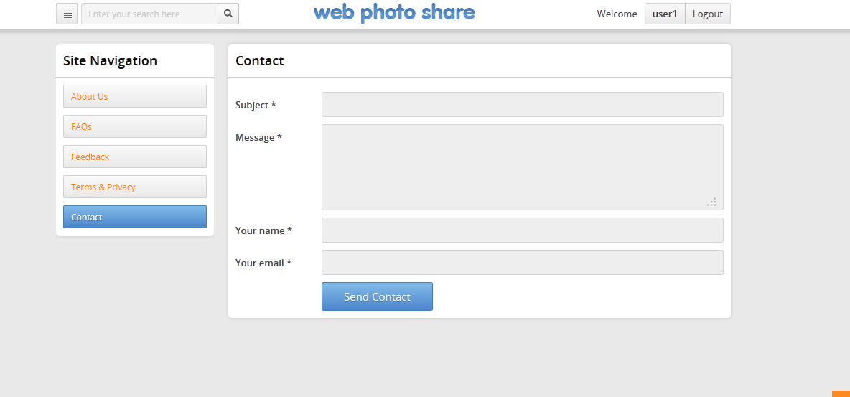

Enter Subject , Message , your name and email

Click Send Contact send comments sent to the admin

# Back-End

## Login to Admin

* Open <http://loccalhost:8080/WebPhotoShare-war/admin>
* username : admin
* password : admin

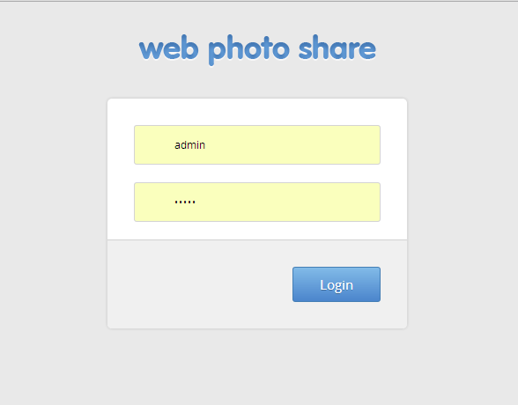

Enter the username of admin

Enter the password of admin

Click button login ! Check the username and password exists or not . if username and password exists, it will display message “login successful” and go to the admin page, if username and password don’t exist , it will display your password were coded

## User Manage

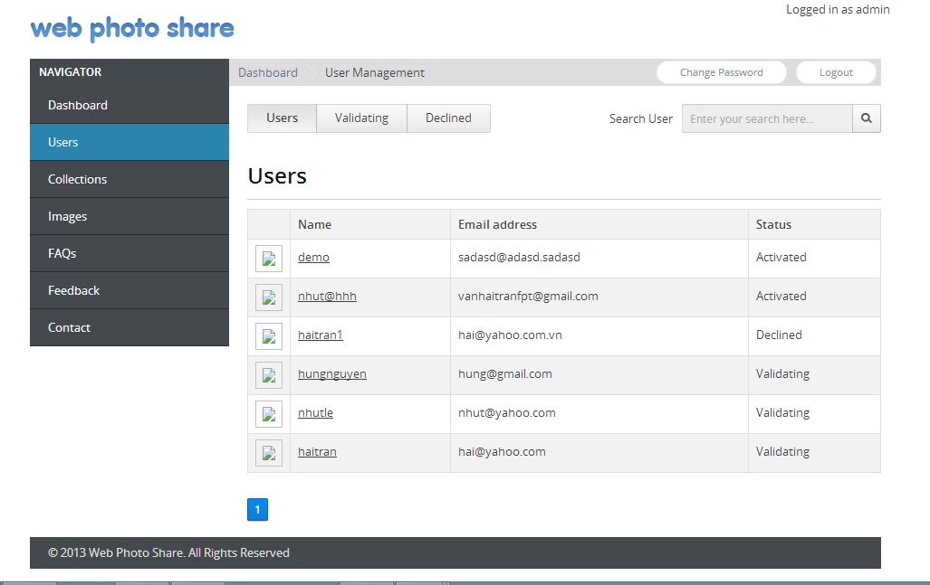

### Click Users display all users

### Click Validating display all users validating

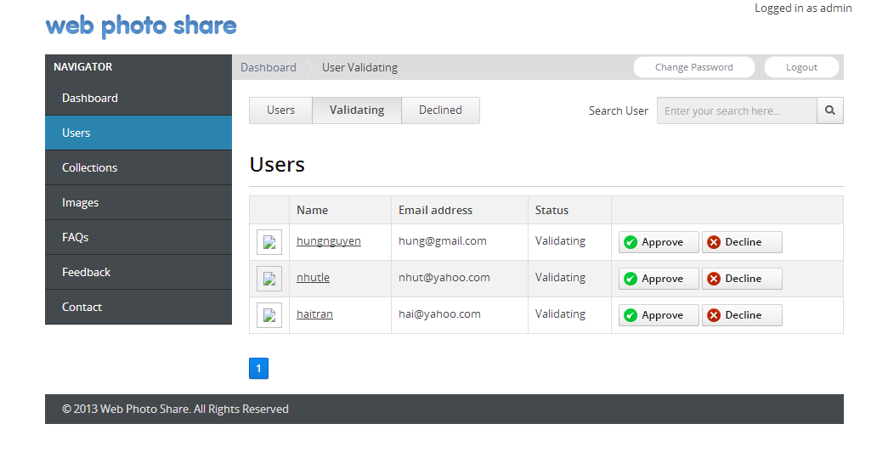

### Click button Approve user will be active and back Users page

### Click button Declined user will be declined and back Users page

### Click Declined display all users declined

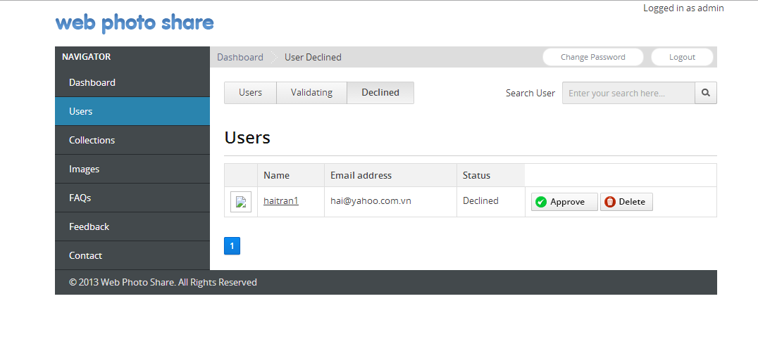

### Click button Approve user will be active and back Users form

### Click button Delete user will be display Delete User Page

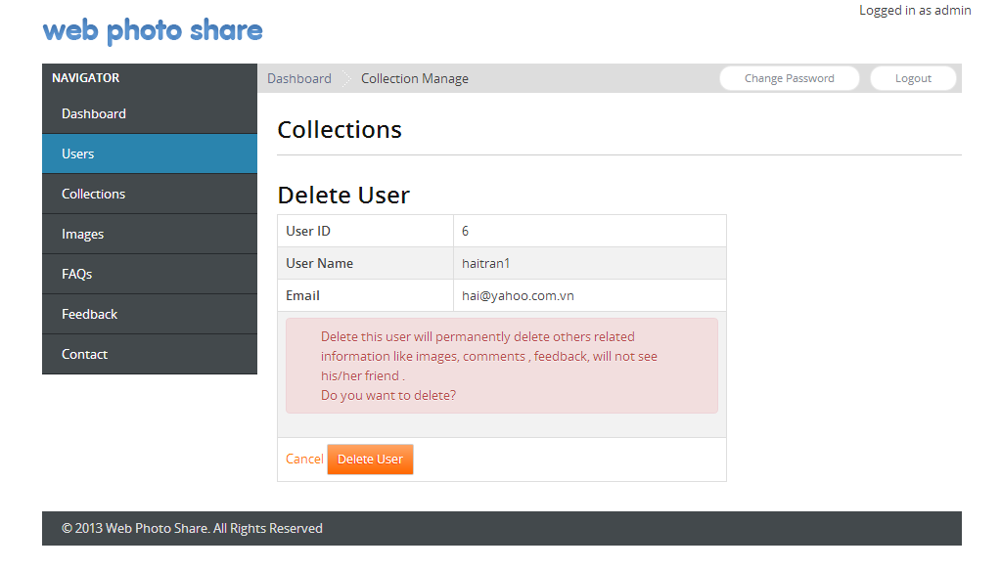

### Click Delete User will be delete user in database

### Click Name display UserEdit Page

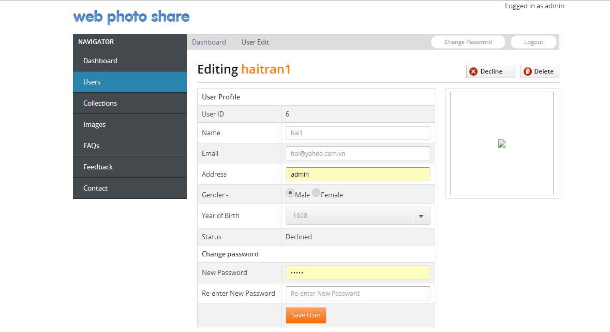

### Click button Declined user will be declined and back Users Page

### Click button Save User save edit users in database and back to User Page

### Click button Delete will be display Delete User Page



### Click Delete User will be delete user in database

## Collection Manage

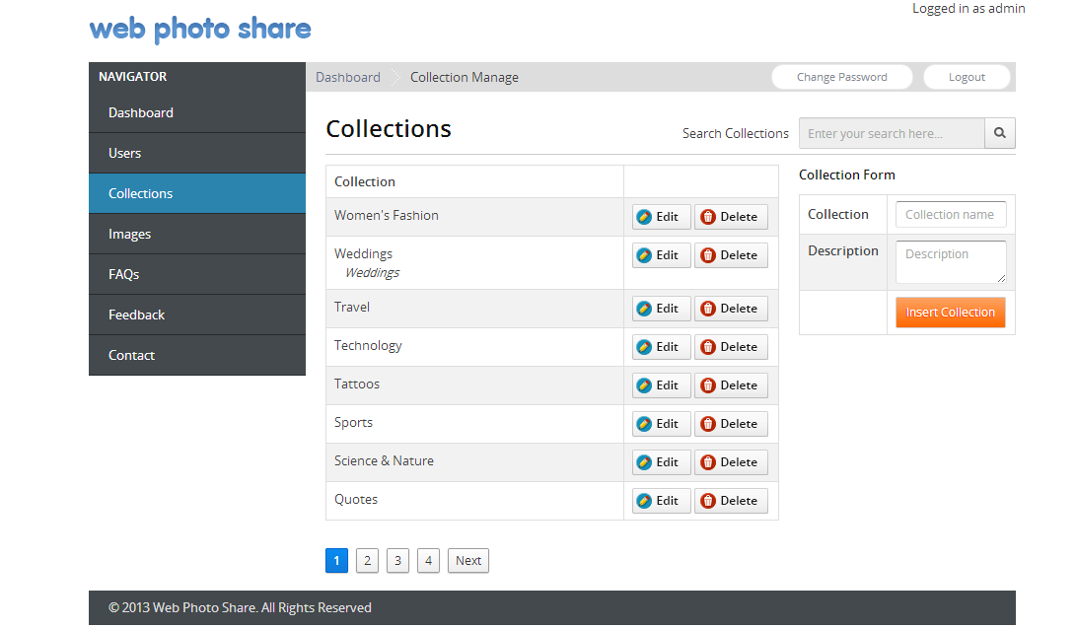

### Click Insert Collection will be insert collection in database

### Click Edit will be Edit Collection

### Click Delete will be Delete Collection page

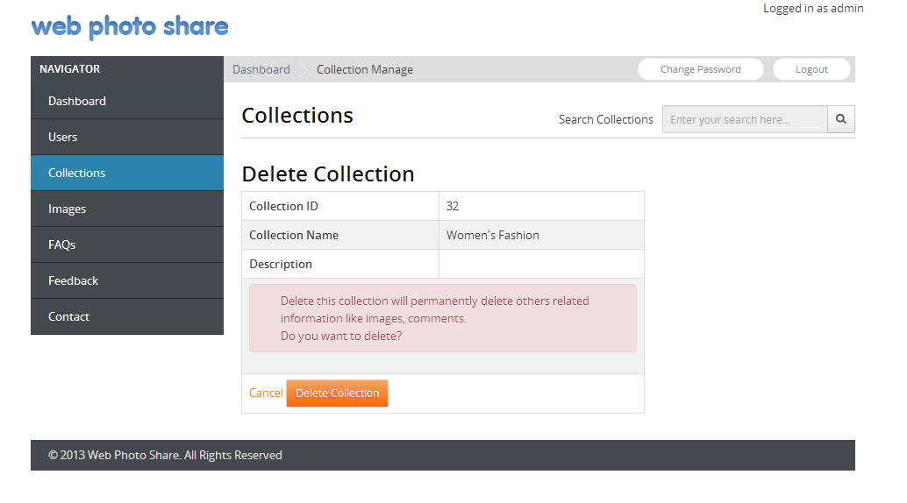

### Click Delete Collection will be delete Collection in database

### Click button Cancel will be back to Collection Page

## Image Manage

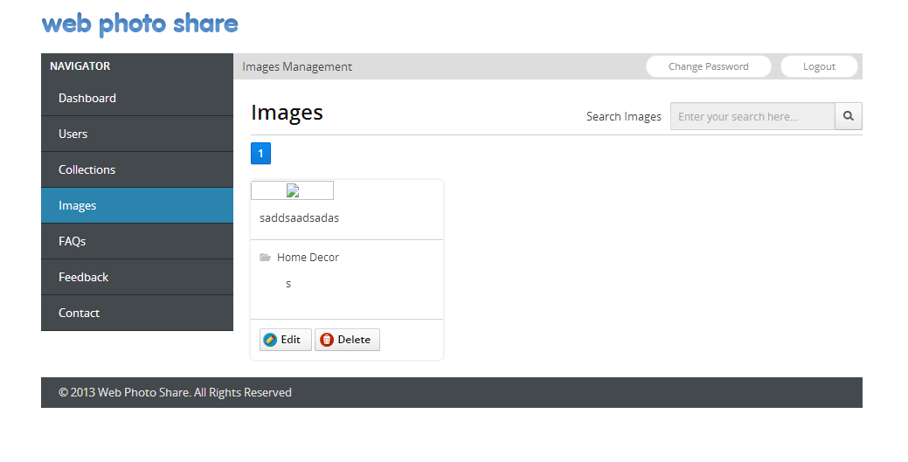

### Click Edit will be display Image Edit

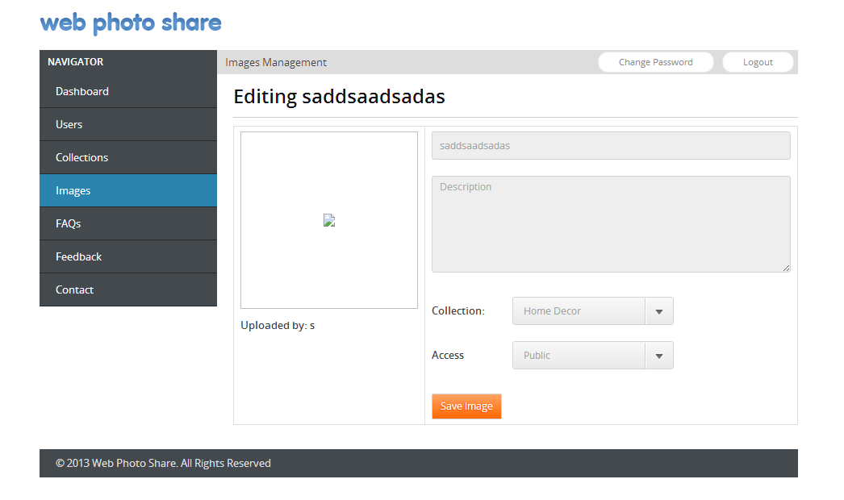

### Click Save Image will be edit Image

### Click Delete will be display Delete Image page

### Click Save Image will be edit Image

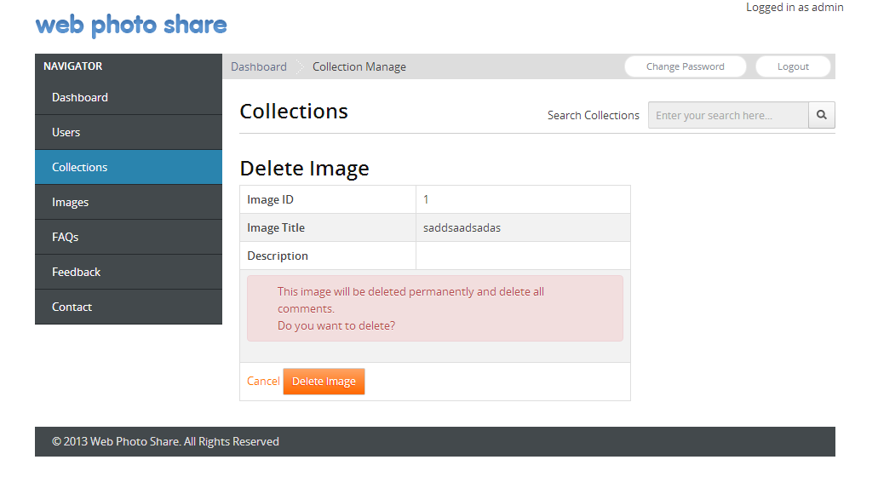

### Click Delete Image will be delete Image

## FAQs

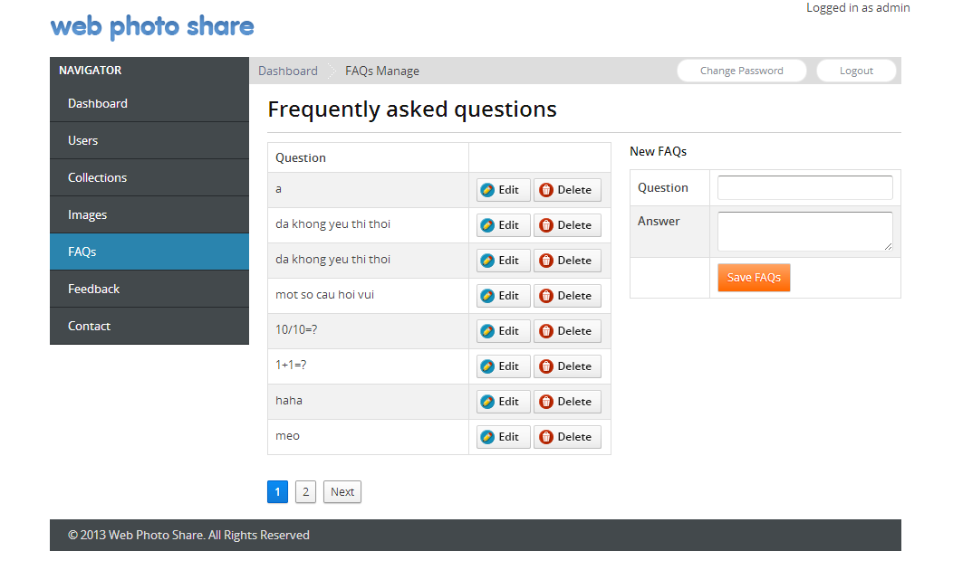

### Click Edit will be edit Faqs

### Click Delete will be delete Faqs

### Click Save FAQs insert new Faqs in database

## FeedBack

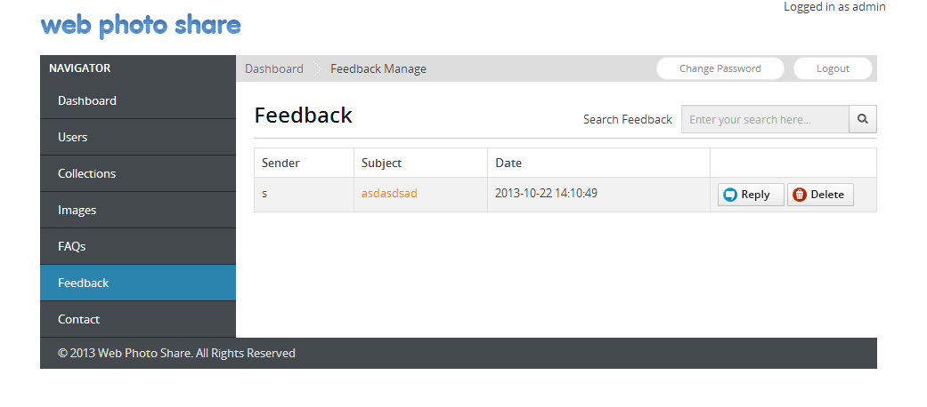

### Click Reply will be display Reply page

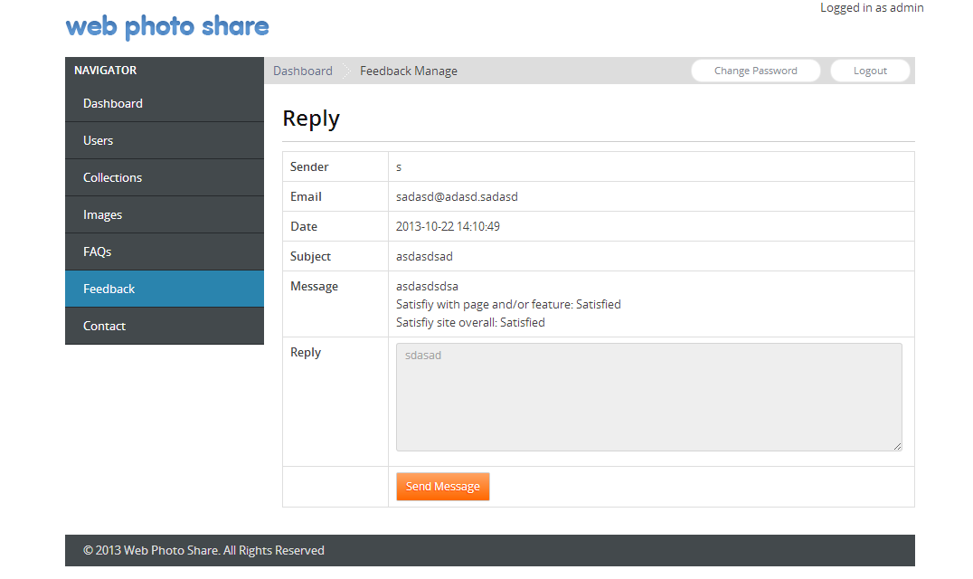

### Click Send Message will be send reply for users

### Click Delete will be delete feedback in database

## Contact Manage

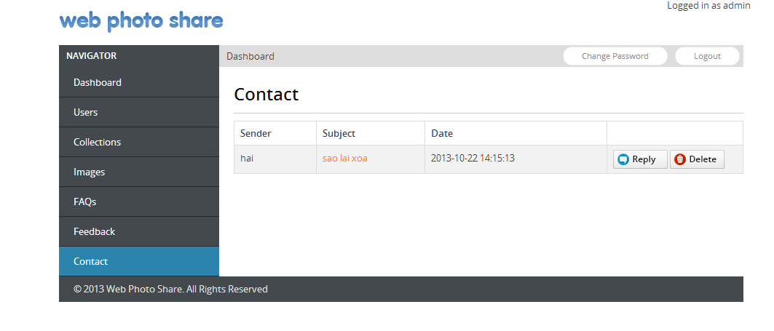

### Click Reply will be display Contact Reply

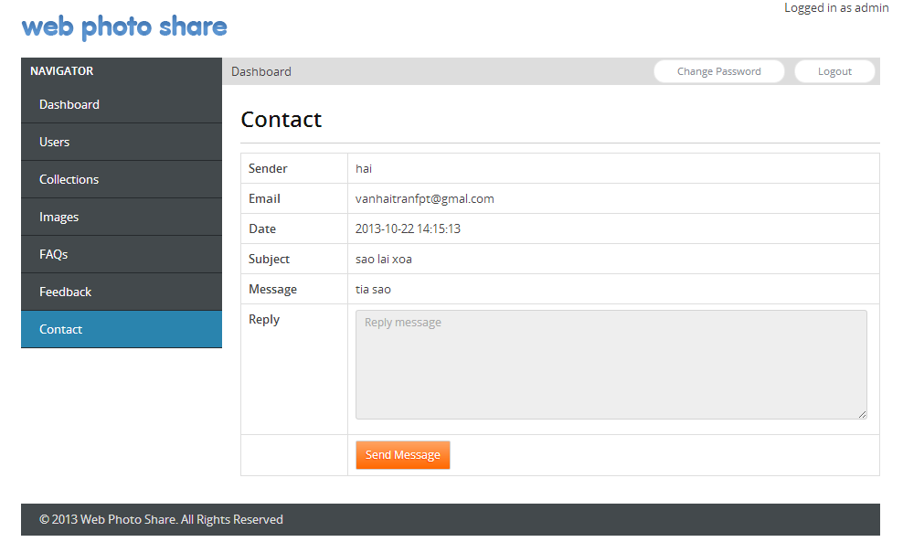

### Click Send Message will be send reply for users

### Click Delete will be delete Contact in database